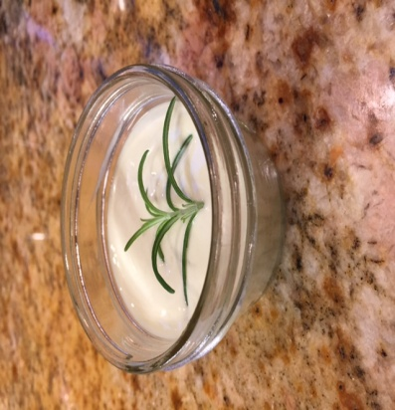
BUSH MEDICINE
Herbs & Healing Studio
Art 2018
Let the healing begin!
Ancient cannabis ways are finding their way back. Join the conversation in an intimate gathering as we chat about strains, tinctures, cooking with cannabis, & nurture it with an soothing palette of creative arts.

Come, relax, inhale, exhale or just ingest---in this intimate class of 8 --it’s all naturally uplifting. Use your Art to heal the world or at the very least yourself! Take home memoirs and treats to savor this journey.
Roots and natural plants are on the menu to elevate your mind and bring new depth to the art created in this workshop. With a sampling of natural cannabis edibles from The West Coast Farmer’s organic garden--.-this workshop promises to fill your plate with more than just art!
This workshop is (absolutely) less fattening and (promises to be quite) fulfilling!
Friday, October 12, 2018
5-7 pm
Cost: $75.00/person (all inclusive—art supplies + cannabis herbal delights + lite cuisine)
Age Restrictions: Adults (25 and over).

Waiver:
By signing this registration application I assume all risk associated with participation of this activity including, but not limited to falls, contact with other participants, the effects of weather, equipment and condition of facilities.
I am over the age of 40 and I am legally able to take part in this workshop. I understand that this is a small private cannabis project and that everything I ingest or inhale is all natural. I accept the responsibility of my behavior during and beyond this workshop in association with the usage of the complimentary samplings.
I do not have any allergic reactions to smoke or cannabis that I know of and I am in good physical condition for this workshop.

Printed Name________________________________________________________Date______________
Signature_____________________________________________________________________________
Cost of Class: _______________ Amount Paid:__________________
Check * Cash * On- line * other _____________________________(Circle one)
Received by: _________________________

Please be sure to bring a printed copy of this signed to the workshop.

